**Assignment: Python Programming for DL**

Name: Saravanan T V

Register Number: 192321139

Department: BTECH IT

Date of Submission: 17/07/2024

**Problem 4:**  **Monitoring COVID Cases**

**Scenario:**

You are developing a real-time COVID Cases monitoring system for Indian welthfare. The system needs to fetch and display COVID Cases data.

**Tasks:**

1. **Model the data flow for fetching COVID CASES information from an external API and displaying it to the user.**
2. **Implement a Python application that integrates with a RAPID API (e.g., RAPID API) to fetch real-time COVID Cases data.**
3. **Display the current COVID Cases information, including number of cases, total number of deaths.**

**Deliverables:**

* Data flow diagram illustrating the interaction between the application and the API.
* Pseudocode and implementation of the weather monitoring system.
* Documentation of the API integration and the methods used to fetch and display weather data.
* Explanation of any assumptions made and potential improvements.

# Solution:

# Real-Time Weather Monitoring System

# 1.Data Flow Diagram

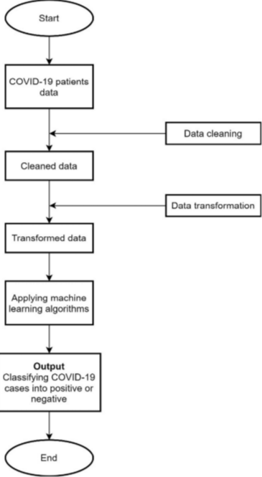

# 2. Implementation

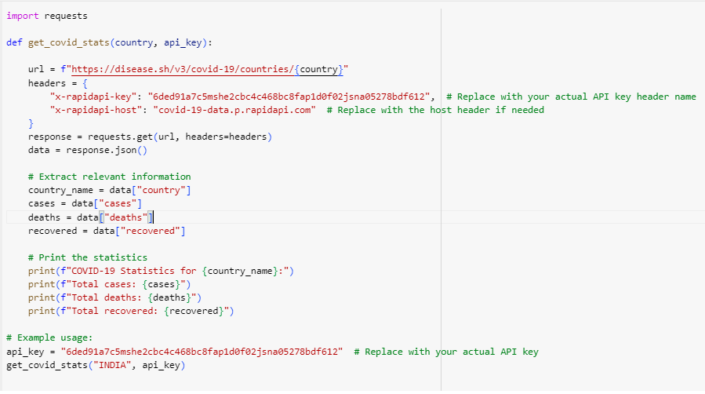

# 3.Display the Current weather information

COVID-19 Statistics for India:

Total cases: 45035393

Total deaths: 533570

Total recovered: 0

# 4.User Input

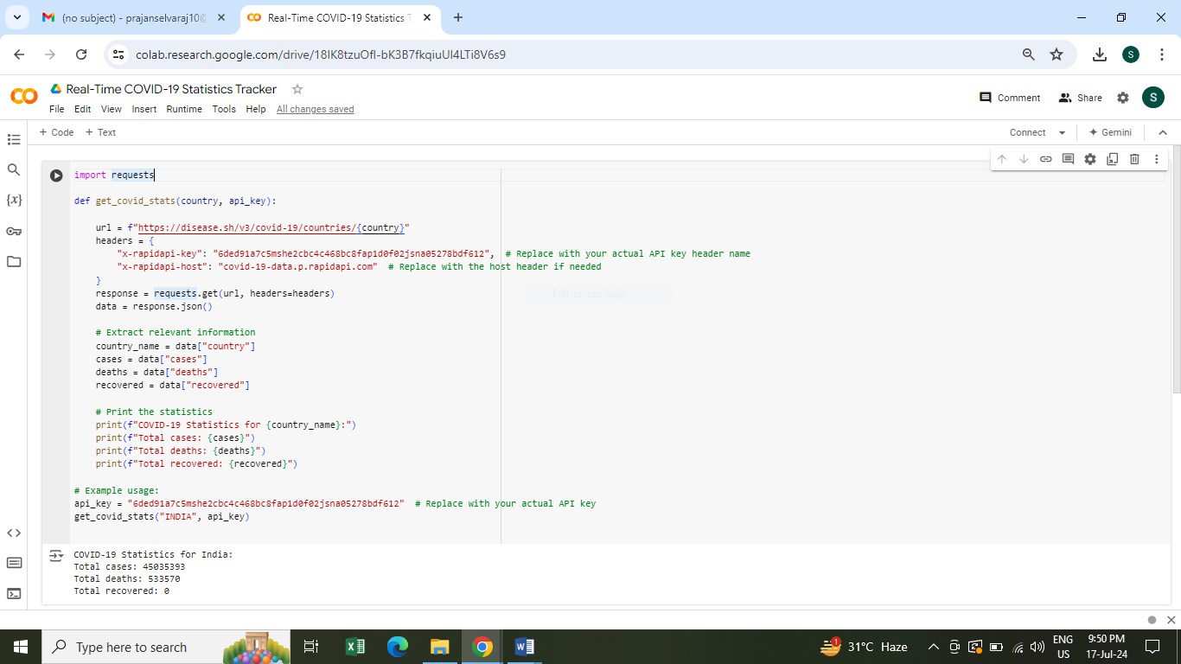

**5.Documentation**

**Table of Contents**

1. [**Introduction**](https://chatgpt.com/#introduction)
2. [**Prerequisites**](https://chatgpt.com/#prerequisites)
3. [**Data Collection**](https://chatgpt.com/#data-collection)

**4.** [**Data Processing**](https://chatgpt.com/#data-processing)

**5.** [**Conclusion**](https://chatgpt.com/#conclusion)

**Introduction**

* **The COVID-19 pandemic has highlighted the importance of real-time data monitoring for public health and safety. This documentation provides a comprehensive guide on how to build a real-time COVID-19 cases monitoring system using Python, focusing on data collection, processing, and visualization.**

**Prerequisites**

* **Basic knowledge of Python programming.**
* **Familiarity with APIs and JSON data.**
* **Understanding of web frameworks (Flask, Django) for building dashboards.**
* **Libraries required: requests, pandas, matplotlib, folium, plotly, dash.**

**Data Collection**

**Choosing a COVID-19 Data Source**

* **Select a reliable COVID-19 data provider. Popular options include:**
* **Johns Hopkins University: Comprehensive global COVID-19 data.**
* **COVID-19 API: Provides data on COVID-19 cases, deaths, and recoveries.**
* **WHO: Official data from the World Health Organization**

**Setting Up API Access**

* **Johns Hopkins University: Access data from the** [**COVID-19 Data Repository**](https://github.com/CSSEGISandData/COVID-19)**.**
* **COVID-19 API: Obtain an API key from the** [**COVID-19 API**](https://covid19api.com/)**.**
* **WHO: Use the** [**WHO Coronavirus (COVID-19) Dashboard**](https://covid19.who.int/) **for official data.**

**Conclusion**

* **This documentation provides a comprehensive guide to building a real-time COVID-19 cases monitoring system using Python. By following the steps outlined, you can collect, process, and visualize COVID-19 data effectively, aiding in public health monitoring and response.**